**Step by Step Instructions for Online Exams**

The student will log in to their account on TheInstitutes.org

Continue to My Online Learning

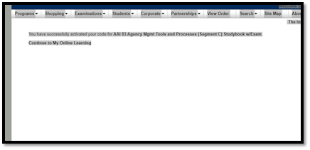

Students will select *Activate your Access Code* to enter the code found printed on the cover of their study book.

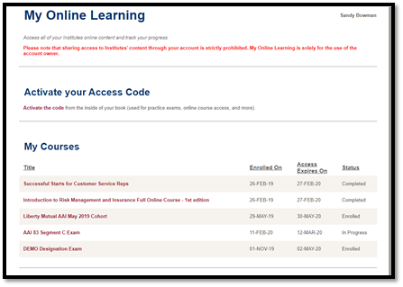

Select **Exam**

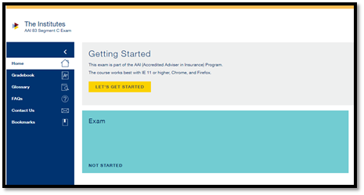

Select **Take Exam**

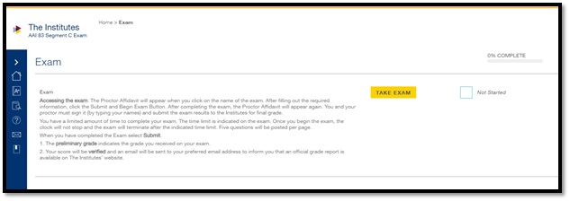

**Begin Attempt**

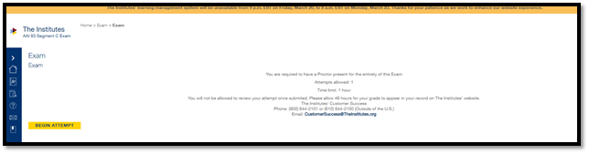

**Proctor Affidavit and Agreement Will Appear – must be completed with**

1. **Student information**
2. **Exam Administration Location**
3. **Proctor Information**

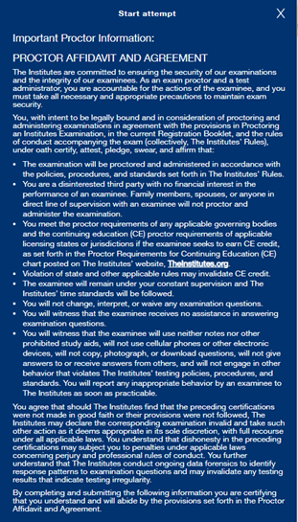

After completing the exam, the Proctor Affidavit will appear again. The student and the proctor must sign it (by typing your names) and submit the exam results to the Institutes for final grade.

**Retake Examinations**

State Associations will order the retake exams just as you have in the past. The difference with the online exam is that it will be in the students account. See below for an example:

